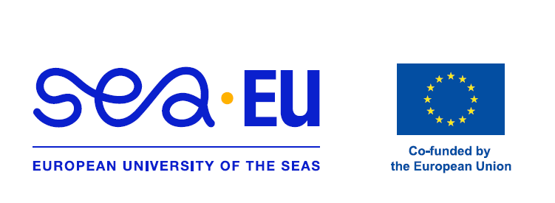

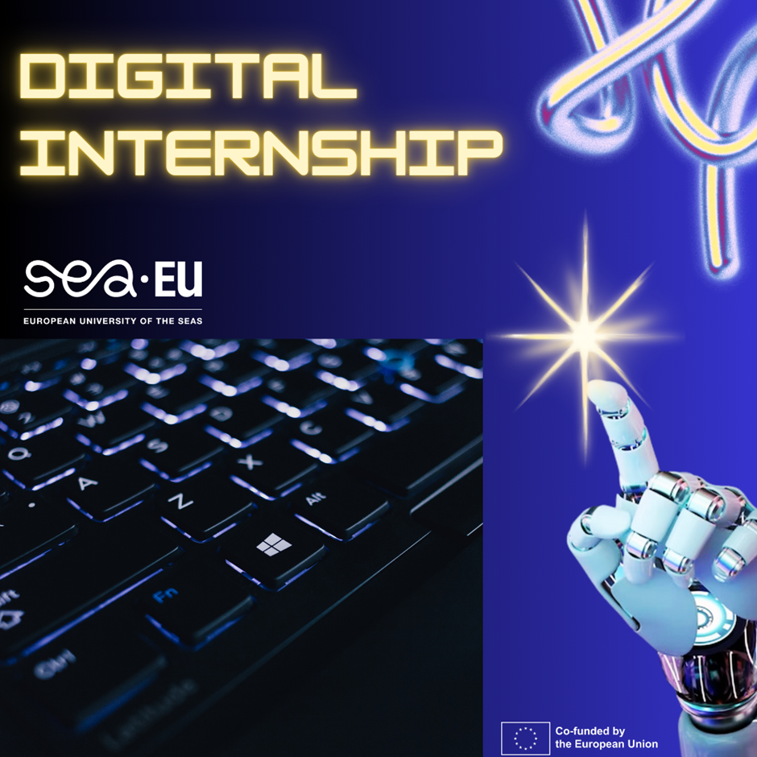



Digital Internships
-----------------------------------------------------------------
Form

Information about the hosting organisation (name, address, a short profile up to 250 words) | University of Gdansk, Centre for Sustainable Development  The Centre for Sustainable Development at the University of Gdańsk (CZRUG) serves as a dynamic hub for research, education, and social impact. Dedicated to the 17 UN Sustainable Development Goals, the Centre offers innovative digital internships tailored for the modern, globalized student. These virtual programs are designed to accommodate a diverse international cohort, primarily requiring proficiency in English as the working language. However, students fluent in Polish, Spanish, French, or German find unique opportunities to support the Centre’s cross-border initiatives and European alliances, like SEA-EU. Through these digital roles, interns develop critical research and analytical skills while shaping global environmental policy.  https://czrug.ug.edu.pl/en/en_start/
Contact person | Magdalena Maciejewska, Joanna Morawska
Email / web page | magdalena.maciejewska@ug.edu.pl; joanna.morawska@ug.edu.pl
Internship offer (short description of main responsibilities) up to 350 words | Organisation of international 11th Living Knowledge Conference  Available: March-July 2026  Number of internships: 3  Join our innovative team for a hybrid internship focused on assisting with the 11th International Living Knowledge Conference (LKN 11), titled "Research and Solidarity", which will be held from July 8–10, 2026, at the University of Gdańsk.  Several key volunteer and internship roles have been identified.  International Communications Liaison: Facilitate contact with global partners (Living Knowledge Network, SEA-EU) and manage English-language correspondence for participants.  Social Media & Digital Content Creator: Live-documenting sessions, managing the conference Twitter/X and LinkedIn, and creating video recaps of "dilemma sessions."  On-Site Logistics & Hospitality: Managing the registration desk at the UG Library, assisting international guests with navigation, and coordinating evening social events.  Session Facilitator Support: Assisting moderators during interactive workshops and "Science Shop" sessions to ensure smooth technical and participatory flow.  Required Skills  Languages: Advanced in English is mandatory (conference language). Competencies: Organizational skills, adaptability, and an interest in community-based participatory research (CBPR).
Duration (no. of weeks and hours per week) | 3 Months/12 weeks/~10h per week
This internship is designed to be an inspiring and joyful journey, blending high-impact contribution with a stress-free pace that respects your academic life. We believe that professional growth should be as flexible as it is rewarding!
- Your Weekly Rhythm: Expect a light and manageable commitment of approximately 5-10 hours per week.
- Work Your Way: This role is fully asynchronous, giving you the freedom to tackle tasks whenever you feel most productive. To keep you energized and on track, we’ll have a quick, 30-minute weekly virtual coffee/check-in with your mentor for guidance and friendly feedback.
- The Creative Goal: You’ll be at the heart of our "Research and Solidarity" mission! Your main focus is identifying and localizing 20+ key "engagement scenes" or clips per week. (Don’t worry—annotation is a completely optional bonus if you want to dive deeper, but our lab team is happy to handle that part!).
- Team Support: You’ll never work in a vacuum. Your mentor is always a message away to ensure you feel confident, supported, and efficient.
By joining us, you’ll gain hands-on experience in cutting-edge conference curation and digital data, all while contributing to a global movement for social good.

Learning outcomes | Upon successfully completing this virtual internship with the LKN 11 Organizing Team, you will be able to:  - Articulate the vital role of "Research and Solidarity" in modern science, specifically how global conferences bridge the gap between academic experts and local communities.  - Execute the end-to-end process of international event curation, from managing diverse abstract submissions and thematic selection to digital storytelling and participant engagement.  - Evaluate the challenges of inclusivity and global representation by consciously highlighting diverse voices, cultures, and grassroots initiatives from the global Living Knowledge Network.  - Construct a professional portfolio of your digital contributions—including curated session reports, media content, or community datasets—demonstrating your direct impact on a major international scientific event.  These outcomes are designed to equip you with tangible, in-demand skills in international project management, digital communication, and sustainable social innovation.
Assessment method(s) | Your performance and learning progress will be evaluated continuously through a combination of quantitative and qualitative methods, focusing on the quality, consistency, and growth you demonstrate throughout the program.  Primary Assessment Methods:  - The "Digital Portfolio" Showcase  - Reflective "Micro-Logs"  - The 360° "Virtual Coffee" Chat  - Mentor Feedback & Progressive Improvement: Your responsiveness to weekly feedback and your ability to incorporate guidance to improve the quality of your subsequent work will be a key qualitative measure of your adaptability and commitment to learning.
Additional note | The initial 2 weeks will be used for training on the context of the conference and Science Shops.
Entry requirements | Students in a program related to any field.

Note: Upon successful completion of the internship, the student will be awarded a certificate. Recognition of the internship is subject to the university’s internal policies.

