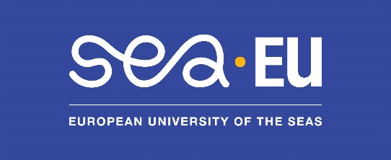

Staff Week - Communicating in English for Research
Brest — 26-28 May 2026
-----------------------------------------------------------------
General information

Staff Week Title | Communicating in English for Research
Abstract: (a few lines describing the staff week that SEA-EU partners can use for dissemination) | Most researchers are able to write about their research, using various online resources and services offered by our universities. When it comes to speaking in public, however, stress and lack of practise sometimes make it difficult to communicate efficiently. Socializing around events and small talk can also be challenging since they are remote from researchers’ field of expertise. This staff week aims to overcome the difficulties most commonly experienced in research.
Application deadline | 16th March 2026
Dates of the staff week | 26-28 May 2026
Number of participants | The number of participants is 24.  Each SEA-EU university can propose up to 3 participants.
Mobility costs | Travel expenses and accommodation can be covered through Erasmus+ Staff Mobility Erasmus (KA103)
Contact | For pedagogical contents: gwenola.legall@univ-brest.fr  For logistical contents: mobilite.internationale@univ-brest.fr

Contents

Target group / Expected profile of participants | Researchers
Requirements | B1+/B2 level minimum in English.  You should be able to participate in a course that is fully conducted in English, and present some research material in English
Agenda | 9-12 am / 2-5pm  Lunch and evening meals will be opportunities to practice small talk.  Day 1: Introducing one another, describing your field of research (mini presentations), presenting your laboratory.  Methodology for effective scientific writing (depending of participants’ needs)  Day 2: Describing graphs and trends, structuring your presentation, storytelling, question & answer sessions  A visit in English (understanding a different accent and interacting with the guide)  Day 3: speaking at a conference – practice and feedback, including Q&A questions. Networking with local colleagues, Organizing and participating in a meeting, cross-cultural differences.

Practical information

Accommodation | A welcome booklet will be sent to the registered participants.
Address of the course | Faculté des Lettres et Sciences Humaines, Brest, France.  Details of the rooms will be sent to participants after registration.
How to join the Staff Week | Please contact the office in charge of mobility within your institution to apply for an Erasmus mobility grant.  Once selected by your university, you will receive a registration form.

